📘 DENDRITES (DNDX) — TOKENOMICS OVERVIEW

1. Executive Summary
Dendrites (DNDX) is designed as the economic backbone of a commerce-grade trust layer built for predictable transaction fees, safer payments, programmable escrow, and AI-assisted dispute handling.
The tokenomics model is structured to ensure:
- Long-term alignment between founders, contributors, and the community
- Controlled early float (6–9% at TGE) to prevent inflationary surges
- Institutional-grade vesting structures that promote stability
- Clear utility across Predictable Gas™, SafetySend (UNDO), and APP Escrow
DNDX has a fixed total supply of 7.6 billion tokens, with all allocations subject to cliffs, linear vesting, or governance controls.

2. Total Supply & Supply Cap
- Total Token Supply: 7,600,000,000 DNDX
- Supply Type: Fixed
- Minting: No additional minting allowed
- Inflation: 0% (permanent fixed cap)
- Burns: Only via governance-approved mechanisms
The fixed cap ensures that the token aligns with long-term sustainable economics rather than inflationary token emissions.

Category | % of Supply | Tokens
Sale & Strategic | 24% | 1,824,000,000
Founder Allocation | 20% | 1,520,000,000
Team & ESOP | 8% | 608,000,000
Community Rewards | 12% | 912,000,000
Ecosystem & Partnerships | 12% | 912,000,000
Liquidity | 8% | 608,000,000
Treasury & Safety Reserves | 16% | 1,216,000,000

All categories have cliff + vesting schedules, except Treasury (governed unlocks only).

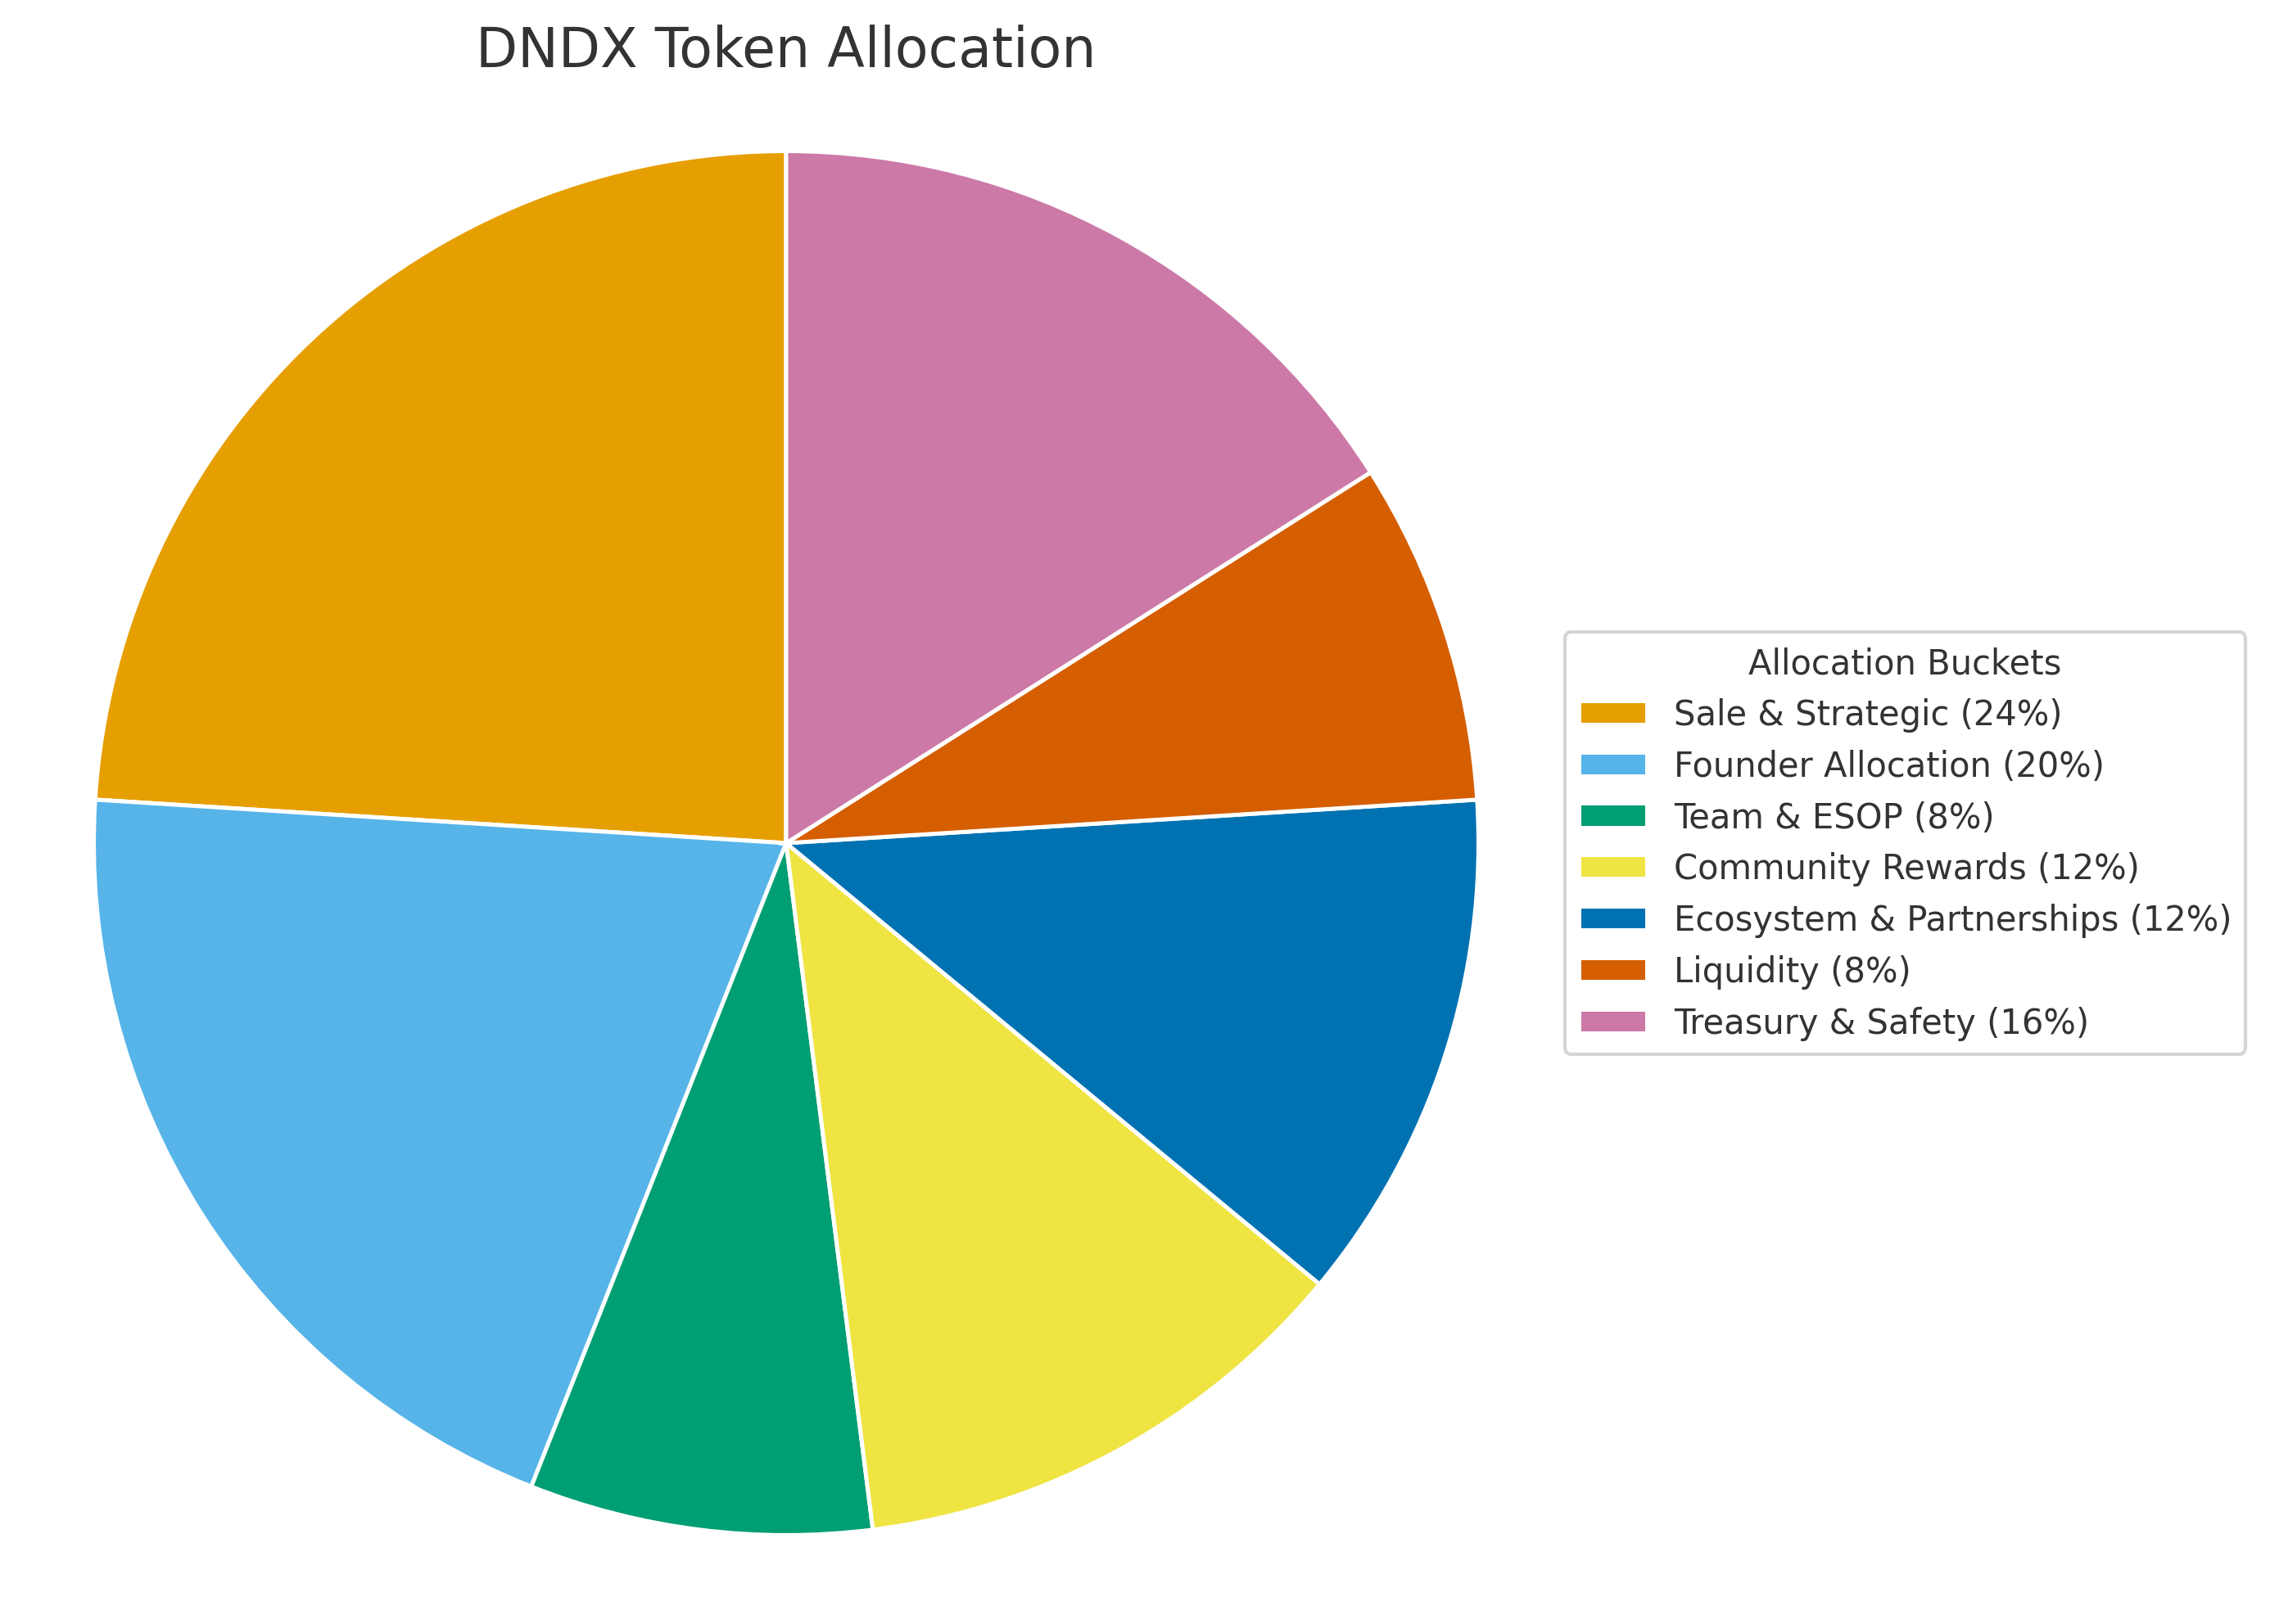

4. Detailed Allocation Breakdown
4.1 Sale & Strategic — 24% (1.824B DNDX)
Purpose: All external token distributions across the lifespan of the project — including community programs, strategic partners, and future launch requirements.
Public Rules:
- All allocations within this bucket have vesting (no 100% TGE unlocks).
- This bucket alone does not determine TGE float — TGE float remains fixed at ~6–9% across all categories.
- Exact sale schedules, rounds, unlock percentages, or pricing are not disclosed publicly.
Vesting Model (conceptual):
$$V_{\text{sale}}(t)=\{\begin{matrix}0 & t<t_{c} \\ A \frac{(t-t_{c})}{T_{\text{vest}}} & t≥t_{c}\end{matrix}$$

4.2 Founder Allocation — 20% (1.52B DNDX)
Purpose: Reward and align the founding contributor(s) over multiple years.
Structure:
- Cliff: 12 months from TGE
- Vesting: 36 months linear post-cliff
- TGE Unlock: 0%
Formula:
$$V_{\text{founder}}(t)=\{\begin{matrix}0 & t<t_{c,founder} \\ A_{founder} \frac{(t-t_{c,founder})}{T_{founder}} & t≥t_{c,founder}\end{matrix}$$
This is a serious project signal showing long-term founder commitment.

4.2 Founder Allocation — 20% (1.52B DNDX)
Purpose: Reward and align the founding contributor(s) over multiple years.
Structure:
- Cliff: 12 months from TGE
- Vesting: 36 months linear post-cliff
- TGE Unlock: 0%
Formula:
$$V_{\text{founder}}(t)=\{\begin{matrix}0 & t<t_{c,founder} \\ A_{founder} \frac{(t-t_{c,founder})}{T_{founder}} & t≥t_{c,founder}\end{matrix}$$
This is a serious project signal showing long-term founder commitment.

4.3 Team & ESOP — 8% (608M DNDX)
Purpose: Supports hiring, advisor compensation, and long-term contributors.
Structure:
- Cliff: 9 months
- Vesting: 36 months linear
- TGE Unlock: 0%
Formula:
$$V_{\text{team}}(t)=\{\begin{matrix}0 & t<t_{c,team} \\ A_{team} \frac{(t-t_{c,team})}{T_{team}} & t≥t_{c,team}\end{matrix}$$
This ensures responsible, sustainable contributor rewards.

4.4 Community Rewards — 12% (912M DNDX)
Purpose: Reward real, verifiable engagement — not free speculative drops.
Used for:
- On-chain actions
- App usage
- Quests and loyalty programs
- Behavior-vested earning
- Long-term contributor programs
Public Principles:
- No fully liquid airdrop at TGE
- Most rewards are earned and then vested
- Encourages actual protocol usage
Formula (generalized):
User earns points or rewards:
$$E_{user}(t)=f(\text{usage, loyalty, tiers})$$
Vesting applied:
$$V_{comm}(t)=\text{vesting_schedule}(E_{user}(t))$$

4.5 Ecosystem & Partnerships — 12% (912M DNDX)
Purpose: Growth, integrations, developer grants, global expansion.
Vesting:
- Typically 3 to 36 months
- Milestone-based unlocks for larger integrations
- No instant, unlimited unlocks
Formula:
$$V_{\text{partner}}(t)=\{\begin{matrix}0 & t<t_{c,partner} \\ A_{partner} \frac{(t-t_{c,partner})}{T_{partner}} & t≥t_{c,partner}\end{matrix}$$

4.6 Liquidity — 8% (608M DNDX)
Purpose:
- DEX & CEX liquidity pools
- Market maker arrangements
- Ensure deep order books
Structure:
- LP tokens locked for 6–12 months
- Market MAKER unlocks tied to liquidity performance
Formula:
$$V_{LP}(t)=\{\begin{matrix}0 & t<t_{\text{unlock}} \\ A_{LP} & t≥t_{\text{unlock}}\end{matrix}$$

4.7 Treasury & Safety Reserves — 16% (1.216B DNDX)
Purpose:
- Fund protocol development
- Support SLA credit issuance
- Handle emergencies
- Operations and audits
- Long-term sustainability
Unlock Logic:
Governance-controlled, slow, transparent, with multi-sig protections.

5. Vesting Architecture
Dendrites follows traditional, institutional-grade vesting.
5.1 Cliff Vesting
Tokens unlock only after the cliff duration is passed.
5.2 Linear Vesting Formula
$$V(t)=\{\begin{matrix}0 & t<t_{c} \\ A⋅\frac{(t-t_{c})}{T} & t≥t_{c}\end{matrix}$$
Where:
- $A$= total allocation
- $t_{c}$= cliff date
- $T$= total vest duration
5.3 Monthly Unlock Amount
$$U=\frac{A}{T}$$

6. Circulating Supply at TGE (Float Model)
To ensure price stability and protect early contributors:
TGE Float Target: ~6–9% of Total Supply
Sources of circulating supply:
- A controlled subset of Sale & Strategic allocations
- Liquidity injections (locked LP positions)
- Some claimable — NOT liquid — community rewards
Everything else remains:
- Cliff locked
- Vesting linearly
- Or governance-locked
This avoids unhealthy inflation and positions DNDX as a serious, institutional-grade protocol token, not a meme launch.

7. Token Utility
DNDX provides utility across the entire economic flywheel of the Dendrites protocol:
- Predictable Gas™: Fee offsets & stability
- SLA Credits: Compensation for fee-band breaches
- SafetySend (UNDO): Reversible transactions
- APP Escrow: Milestone-based settlement
- Priority Access: To premium service tiers
- Ecosystem Access: Staking & participation credits
- Future Governance: Parameter & treasury decisions

8. Economic Design Principles
The DNDX token model follows:
1. Long-Term Alignment
Founder and team locked for 9–12 months (cliffs), then vest 3 years.
2. Controlled Liquidity
Early circulating supply capped tightly.
3. Usage-Based Community Rewards
Earned through real behavior.
4. Sustainable Treasury Policy
Reserves unlock slowly via governance.

9. Compliance Notes (Public-Safe)
This document:
- Does not contain token pricing
- Does not contain sale schedules
- Does not promise returns or profits
- Is not a solicitation or offering
- Is for educational and transparency purposes only
Any participation in token-related programs will require separate, jurisdiction-specific terms.

10. Final Summary Table
Category | % | Vesting
Sale & Strategic | 24% | Cliffs + linear vesting
Founder | 20% | 12m cliff + 36m linear
Team | 8% | 9m cliff + 36m linear
Community Rewards | 12% | Earned + vested
Ecosystem | 12% | 3–36m vesting
Liquidity | 8% | 6–12m lock
Treasury | 16% | Governed unlocks

This tokenomics model is built for long-term stability, predictable growth, and responsible governance.
With a fixed supply, disciplined vesting, and controlled TGE circulation, DNDX aligns all stakeholders toward the same mission — building the world’s most trusted, commerce-grade payment layer.

